МИНОБРНАУКИ РОССИИ

Федеральное государственное бюджетное образовательное учреждение высшего образования

«Ижевский государственный технический университет

имени М.Т. Калашникова»

Институт «Информатика и вычислительная техника»

Кафедра «Программное обеспечение»

Лабораторная работа №2

# подисциплине «Архитектура электронно-вычислительных машин»

Выполнил:

студент группы Б04-191-3 Р. А. Гумметов

Принял: А. Х. Аль Аккад

Ижевск 2020

Цель работы

C использованием приложения QuartusPrimeLiteEdition, реализовать задание для практических занятий:

- Создать диаграмму.

- Получить VHDL.

- Сделать симуляцию дизайна.

Сумматор 1 бит

1. Построение диаграммы

Диаграмма представлена на рисунке 1:

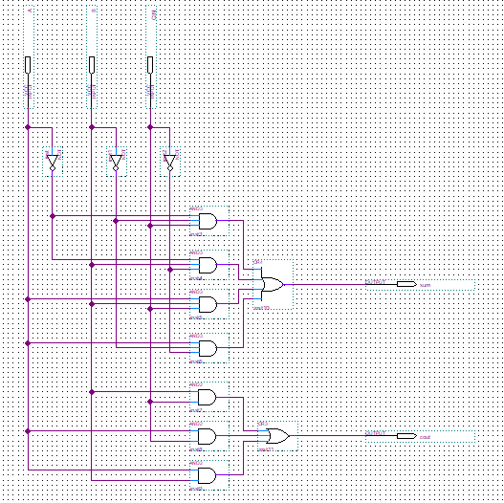

Рис. 1. Диаграмма сумматора 1 бит.

1. VHDL

-- Copyright (C) 2019 Intel Corporation. All rights reserved.

-- Your use of Intel Corporation's design tools, logic functions

-- and other software and tools, and any partner logic

-- functions, and any output files from any of the foregoing

-- (including device programming or simulation files), and any

-- associated documentation or information are expressly subject

-- to the terms and conditions of the Intel Program License

-- Subscription Agreement, the Intel Quartus Prime License Agreement,

-- the Intel FPGA IP License Agreement, or other applicable license

-- agreement, including, without limitation, that your use is for

-- the sole purpose of programming logic devices manufactured by

-- Intel and sold by Intel or its authorized distributors. Please

-- refer to the applicable agreement for further details, at

-- https://fpgasoftware.intel.com/eula.

-- PROGRAM "Quartus Prime"

-- VERSION "Version 19.1.0 Build 670 09/22/2019 SJ Lite Edition"

-- CREATED "Thu Apr 09 13:31:43 2020"

LIBRARY ieee;

USE ieee.std_logic_1164.all;

LIBRARY work;

ENTITY laba2 IS

PORT

(

A : IN STD_LOGIC;

B : IN STD_LOGIC;

CIN : IN STD_LOGIC;

sum : OUT STD_LOGIC;

cout : OUT STD_LOGIC

);

END laba2;

ARCHITECTURE bdf_type OF laba2 IS

SIGNAL SYNTHESIZED_WIRE_0 : STD_LOGIC;

SIGNAL SYNTHESIZED_WIRE_1 : STD_LOGIC;

SIGNAL SYNTHESIZED_WIRE_2 : STD_LOGIC;

SIGNAL SYNTHESIZED_WIRE_3 : STD_LOGIC;

SIGNAL SYNTHESIZED_WIRE_4 : STD_LOGIC;

SIGNAL SYNTHESIZED_WIRE_5 : STD_LOGIC;

SIGNAL SYNTHESIZED_WIRE_6 : STD_LOGIC;

SIGNAL SYNTHESIZED_WIRE_13 : STD_LOGIC;

SIGNAL SYNTHESIZED_WIRE_14 : STD_LOGIC;

SIGNAL SYNTHESIZED_WIRE_15 : STD_LOGIC;

BEGIN

SYNTHESIZED_WIRE_13 <= NOT(A);

SYNTHESIZED_WIRE_14 <= NOT(B);

sum <= SYNTHESIZED_WIRE_0 OR SYNTHESIZED_WIRE_1 OR SYNTHESIZED_WIRE_2 OR SYNTHESIZED_WIRE_3;

cout<= SYNTHESIZED_WIRE_4 OR SYNTHESIZED_WIRE_5 OR SYNTHESIZED_WIRE_6;

SYNTHESIZED_WIRE_15 <= NOT(CIN);

SYNTHESIZED_WIRE_0 <= SYNTHESIZED_WIRE_13 AND SYNTHESIZED_WIRE_14 AND CIN;

SYNTHESIZED_WIRE_3 <= SYNTHESIZED_WIRE_13 AND B AND SYNTHESIZED_WIRE_15;

SYNTHESIZED_WIRE_1 <= A AND B AND CIN;

SYNTHESIZED_WIRE_2 <= A AND SYNTHESIZED_WIRE_14 AND SYNTHESIZED_WIRE_15;

SYNTHESIZED_WIRE_6 <= B AND CIN;

SYNTHESIZED_WIRE_4 <= A AND CIN;

SYNTHESIZED_WIRE_5 <= A AND B;

END bdf_type;

1. Симуляция дизайна

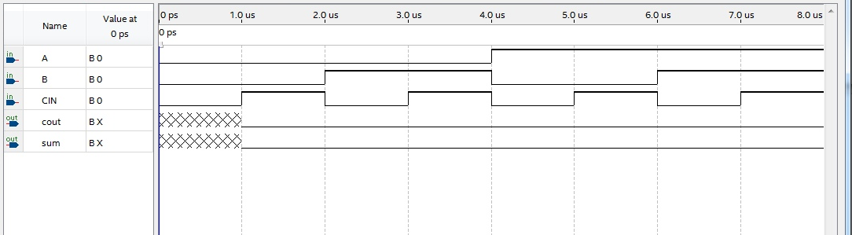

Счетчик 4 бита

1. Построение диаграммы

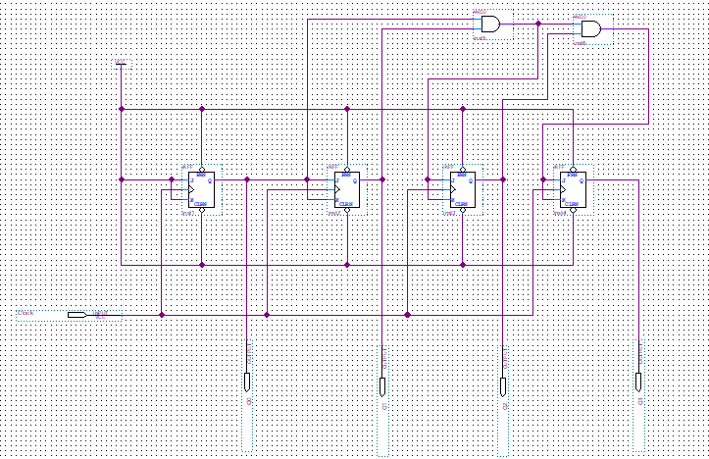

1. VHDL

-- Copyright (C) 2019 Intel Corporation. All rights reserved.

-- Your use of Intel Corporation's design tools, logic functions

-- and other software and tools, and any partner logic

-- functions, and any output files from any of the foregoing

-- (including device programming or simulation files), and any

-- associated documentation or information are expressly subject

-- to the terms and conditions of the Intel Program License

-- Subscription Agreement, the Intel Quartus Prime License Agreement,

-- the Intel FPGA IP License Agreement, or other applicable license

-- agreement, including, without limitation, that your use is for

-- the sole purpose of programming logic devices manufactured by

-- Intel and sold by Intel or its authorized distributors. Please

-- refer to the applicable agreement for further details, at

-- https://fpgasoftware.intel.com/eula.

-- PROGRAM "Quartus Prime"

-- VERSION "Version 19.1.0 Build 670 09/22/2019 SJ Lite Edition"

-- CREATED "Thu Apr 09 14:16:40 2020"

LIBRARY ieee;

USE ieee.std_logic_1164.all;

LIBRARY work;

ENTITY project IS

PORT

(

Clock : IN STD_LOGIC;

Q0 : OUT STD_LOGIC;

Q1 : OUT STD_LOGIC;

Q2 : OUT STD_LOGIC;

Q3 : OUT STD_LOGIC

);

END project;

ARCHITECTURE bdf_type OF project IS

SIGNAL SYNTHESIZED_WIRE_15 : STD_LOGIC;

SIGNAL SYNTHESIZED_WIRE_16 : STD_LOGIC;

SIGNAL SYNTHESIZED_WIRE_17 : STD_LOGIC;

SIGNAL SYNTHESIZED_WIRE_18 : STD_LOGIC;

SIGNAL JKFF_inst2 : STD_LOGIC;

SIGNAL JKFF_inst3 : STD_LOGIC;

BEGIN

Q0 <= SYNTHESIZED_WIRE_16;

Q1 <= JKFF_inst2;

Q2 <= JKFF_inst3;

SYNTHESIZED_WIRE_15 <= '1';

PROCESS(Clock,SYNTHESIZED_WIRE_15,SYNTHESIZED_WIRE_15)

VARIABLE synthesized_var_for_SYNTHESIZED_WIRE_16 : STD_LOGIC;

BEGIN

IF (SYNTHESIZED_WIRE_15 = '0') THEN

synthesized_var_for_SYNTHESIZED_WIRE_16 := '0';

ELSIF (SYNTHESIZED_WIRE_15 = '0') THEN

synthesized_var_for_SYNTHESIZED_WIRE_16 := '1';

ELSIF (RISING_EDGE(Clock)) THEN

synthesized_var_for_SYNTHESIZED_WIRE_16 := (NOT(synthesized_var_for_SYNTHESIZED_WIRE_16) AND SYNTHESIZED_WIRE_15) OR (synthesized_var_for_SYNTHESIZED_WIRE_16 AND (NOT(SYNTHESIZED_WIRE_15)));

END IF;

SYNTHESIZED_WIRE_16 <= synthesized_var_for_SYNTHESIZED_WIRE_16;

END PROCESS;

PROCESS(Clock,SYNTHESIZED_WIRE_15,SYNTHESIZED_WIRE_15)

VARIABLE synthesized_var_for_JKFF_inst2 : STD_LOGIC;

BEGIN

IF (SYNTHESIZED_WIRE_15 = '0') THEN

synthesized_var_for_JKFF_inst2 := '0';

ELSIF (SYNTHESIZED_WIRE_15 = '0') THEN

synthesized_var_for_JKFF_inst2 := '1';

ELSIF (RISING_EDGE(Clock)) THEN

synthesized_var_for_JKFF_inst2 := (NOT(synthesized_var_for_JKFF_inst2) AND SYNTHESIZED_WIRE_16) OR (synthesized_var_for_JKFF_inst2 AND (NOT(SYNTHESIZED_WIRE_16)));

END IF;

JKFF_inst2 <= synthesized_var_for_JKFF_inst2;

END PROCESS;

PROCESS(Clock,SYNTHESIZED_WIRE_15,SYNTHESIZED_WIRE_15)

VARIABLE synthesized_var_for_JKFF_inst3 : STD_LOGIC;

BEGIN

IF (SYNTHESIZED_WIRE_15 = '0') THEN

synthesized_var_for_JKFF_inst3 := '0';

ELSIF (SYNTHESIZED_WIRE_15 = '0') THEN

synthesized_var_for_JKFF_inst3 := '1';

ELSIF (RISING_EDGE(Clock)) THEN

synthesized_var_for_JKFF_inst3 := (NOT(synthesized_var_for_JKFF_inst3) AND SYNTHESIZED_WIRE_17) OR (synthesized_var_for_JKFF_inst3 AND (NOT(SYNTHESIZED_WIRE_17)));

END IF;

JKFF_inst3 <= synthesized_var_for_JKFF_inst3;

END PROCESS;

PROCESS(Clock,SYNTHESIZED_WIRE_15,SYNTHESIZED_WIRE_15)

VARIABLE synthesized_var_for_Q3 : STD_LOGIC;

BEGIN

IF (SYNTHESIZED_WIRE_15 = '0') THEN

synthesized_var_for_Q3 := '0';

ELSIF (SYNTHESIZED_WIRE_15 = '0') THEN

synthesized_var_for_Q3 := '1';

ELSIF (RISING_EDGE(Clock)) THEN

synthesized_var_for_Q3 := (NOT(synthesized_var_for_Q3) AND SYNTHESIZED_WIRE_18) OR (synthesized_var_for_Q3 AND (NOT(SYNTHESIZED_WIRE_18)));

END IF;

Q3 <= synthesized_var_for_Q3;

END PROCESS;

SYNTHESIZED_WIRE_17 <= SYNTHESIZED_WIRE_16 AND JKFF_inst2;

SYNTHESIZED_WIRE_18 <= SYNTHESIZED_WIRE_17 AND JKFF_inst3;

END bdf_type;

1. Симуляция дизайна

